**Wireless Router Configuration Process**

This process document is intended to show the specific steps on how to set up a Wi-Fi environment. The main purpose of this process is to help people understand how to configure a TP-link wireless router.

1. **Physical Connection**
   1. Connect the internet port to the LAN port on the wireless router by using cross-over cable.
2. **Log in**
   1. Open a browser and typing <http://tplinkwifi.net> in the address bar. The login page will show up. A screenshot of a computer

      AI-generated content may be incorrect.
   2. The default password is admin. If the default password has been changed and you don’t know it, hold the reset button behind the router for ten seconds to reset the router (ignore this if you know the password).A close up of a device

      AI-generated content may be incorrect.
   3. Once login successful, the first step is select your time zone. A screenshot of a computer

      AI-generated content may be incorrect.  
      Choose the time zone where you at and click NEXT.
   4. In Personalize Wireless Settings, checked Smart Connect and Wireless Radio. Then, you can set the SSID and the password. A screenshot of a computer

      AI-generated content may be incorrect.  
      Once you completed, click NEXT.
   5. Wait for the connection test to complete. A screenshot of a computer

      AI-generated content may be incorrect.   
      Review the summary and click FINISH.  
      A screenshot of a computer

      AI-generated content may be incorrect.
3. **Network Settings**
   1. Select Internet, in LAN settings, you can configure IP addresses as static or dynamic. A screenshot of a computer

      AI-generated content may be incorrect.
   2. In DHCP Serve settings, you can select the DHCP Server mode and configure the DHCP Pool. A screenshot of a computer

      AI-generated content may be incorrect.
4. **Wireless Settings**
   1. Select Wireless, in Wireless Settings, you can change the configuration that you did before and choose the security type, 2.4G settings and 5G settings. A screenshot of a computer

      AI-generated content may be incorrect.
   2. In Guest Network, you can enable 2.4G channel or 5G channel or both and set security type and password on them to separate the main network. A screenshot of a computer

      AI-generated content may be incorrect.
5. **Advnaced Settings**
   1. Change Password: In Adcanecd -> Administration, you can change your login password or recover password. A screenshot of a computer

      AI-generated content may be incorrect.
   2. Change operation mode. Wireless Router Mode is the default mode, change it to Access Point Mode to let network focus on wireless access and no longer do routing/NAT. 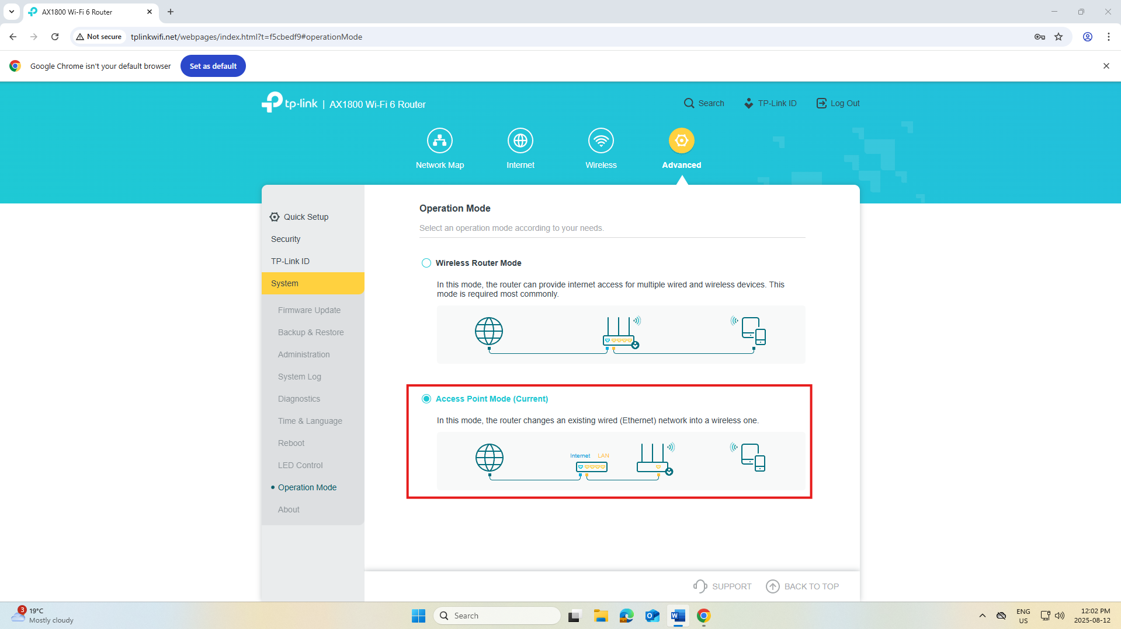
6. **Test Wi-Fi Connection**
   1. Connect to the Wi-Fi by mobile devices, find the SSID, enter the password and test the connection.

The Wi-Fi configuration has succeeded. End of process.